Untitled
2024-01-08
df_conc=read.csv('Concrete_Data1.csv')
head(df_conc)str(df_conc)
## 'data.frame': 1030 obs. of 9 variables:
## $ Cement : num 540 540 332 332 199 ...
## $ Blast.Furnace.Slag: num 0 0 142 142 132 ...
## $ Fly.Ash : num 0 0 0 0 0 0 0 0 0 0 ...
## $ Water : num 162 162 228 228 192 228 228 228 228 228 ...
## $ Superplasticizer : num 2.5 2.5 0 0 0 0 0 0 0 0 ...
## $ Coarse.Aggregate : num 1040 1055 932 932 978 ...
## $ Fine.Aggregate : num 676 676 594 594 826 ...
## $ Age.days. : num 28 28 270 365 360 90 365 28 28 28 ...
## $ Concrete.strength : num 80 61.9 40.3 41 44.3 ...
lm_model <- lm(Concrete.strength ~ ., data = df_conc)
summary(lm_model)
## Multiple R-squared: 0.6155, Adjusted R-squared: 0.6125
## F-statistic: 204.3 on 8 and 1021 DF, p-value: < 2.2e-16
plot(lm_model)
boxplot(df_conc$Concrete.strength ~ df_conc$Age.days., xlab = "Age in days", ylab = "Concrete Strength", main = "Concrete Strength vs. Age")
pairs(df_conc)
library(ggplot2)
library(scales)
# Set the range for the x-axis (Age.days.) and the break point
range_days <- c(0, 400)
break_point <- 50
ggplot(df_conc, aes(x = Age.days., y = Cement, color = Concrete.strength)) +
geom_point(size = 3) + # Use point size for visibility
scale_x_continuous(limits = range_days, breaks = seq(0, range_days[2], by = break_point)) +
scale_color_gradient(low = "tan", high = "darkred", guide = "legend") +
labs(x = "Age (days)", y = "Cement (kg in a m^3 mixture)", color = "Concrete Strength (Mpa)") +
theme_minimal()

library(ggplot2)
# Set the range for the x-axis (Age.days.) and the break point
range_days <- c(0, 400)
break_point <- 50
ggplot(df_conc, aes(x = Cement, y = Concrete.strength, color = Water, size = Water)) +
geom_point() +
labs(x = "Cement (kg in a m^3 mixture)", y = "Concrete Strength (Mpa megapascals)", color = "Water", size = "Water") +
scale_size_continuous(guide = FALSE) + # Remove size legend
guides(color = guide_legend(title = "Water (kg in a m^3 mixture) ")) + # Set a single legend for color
theme_minimal()
library(ggplot2)
ggplot(df_conc, aes(x = Cement, y = Concrete.strength, color = Fly.Ash)) +
geom_point() +
scale_color_gradient(low = "lightgrey", high = "darkslategrey", name = "Fly Ash") +
scale_size_continuous(range = c(2, 8), name = "Fly Ash") +
labs(x = "Cement (kg in a m^3 mixture)", y = "Concrete Strength (MPa, megapascals) ") +
theme_minimal()
# Define intervals for Concrete Strength
df_conc$Strength_Group <- cut(df_conc$Concrete.strength, breaks = c(0, 30, 50, 70, max(df_conc$Concrete.strength)), labels = c("<30", "30-50", "50-70", ">=70"))
# Calculate mean Cement and Fly Ash for each interval of Concrete Strength
aggregate_cement_flyash <- aggregate(cbind(Cement, Fly.Ash) ~ Strength_Group, data = df_conc, FUN = mean)
# Create a bar plot for Cement and Fly Ash on different intervals of Concrete Strength
barplot(t(aggregate_cement_flyash[, c("Cement", "Fly.Ash")]), beside = TRUE,
col = c("darkslategrey", "gray"),
names.arg = aggregate_cement_flyash$Strength_Group,
main = "Mean Cement and Fly Ash on Different Strength Intervals",
xlab = "Concrete Strength Intervals (MPa, megapascals) ", ylab = "Mean Value of Cemennt & FlyAsh")
legend("topright", legend = c("Cement", "Fly Ash"), fill = c("darkslategrey", "gray"))
# Define colors based on Superplasticizer values
colors <- ifelse(df_conc$Superplasticizer < 2, "green",
ifelse(df_conc$Superplasticizer >= 2 & df_conc$Superplasticizer < 4, "blue", "darkorange"))
# Scatter plot of Superplasticizer against Water with colored points
plot(df_conc$Superplasticizer, df_conc$Water,
xlab = "Superplasticizer (kg in a m^3 mixture)", ylab = "Water (kg in a m^3 mixture)",
main = "Relationship between Superplasticizer and Water",
col = colors)
# Adding a trend line
abline(lm(df_conc$Water ~ df_conc$Superplasticizer), col = "red")
# Adding a legend
legend("topright", legend = c("< 2", "2 - 4", ">= 4"), col = c("green", "blue", "darkorange"), pch = 2,
title = "Superplasticizer Range")
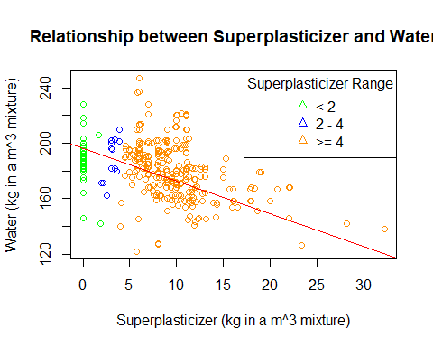
# Define intervals for Concrete Strength
df_conc$Strength_Group <- cut(df_conc$Concrete.strength, breaks = c(0, 30, 50, 70, max(df_conc$Concrete.strength)), labels = c("<30", "30-50", "50-70", ">=70"))
# Calculate mean Cement and Fly Ash for each interval of Concrete Strength
aggregate_cement_flyash <- aggregate(cbind(Cement, Fly.Ash) ~ Strength_Group, data = df_conc, FUN = mean)
# Create a bar plot for Cement and Fly Ash on different intervals of Concrete Strength
barplot(t(aggregate_cement_flyash[, c("Cement", "Fly.Ash")]), beside = TRUE,
col = c("darkslategrey", "gray"),
names.arg = aggregate_cement_flyash$Strength_Group,
main = "Mean Cement and Fly Ash on Different Strength Intervals",
xlab = "Concrete Strength Intervals (MPa, megapascals) ", ylab = "Mean Value of Cemennt & FlyAsh")
legend("topright", legend = c("Cement", "Fly Ash"), fill = c("darkslategrey", "gray"))
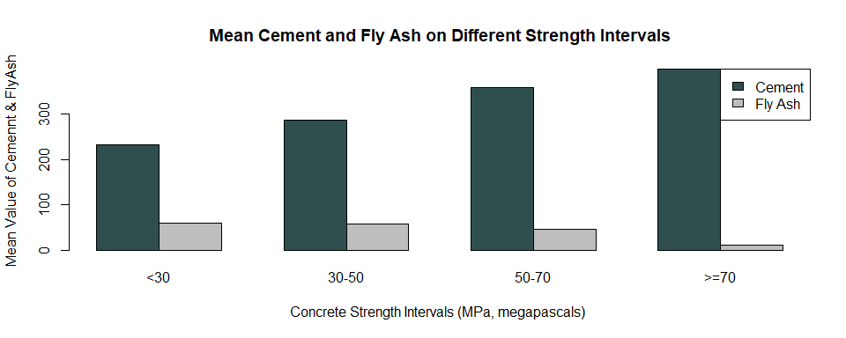
# Calculate mean Water for each interval of Concrete Strength
aggregate_water <- aggregate(Water ~ Strength_Group, data = df_conc, FUN = mean)
# Create a bar plot for Cement and Fly Ash on different intervals of Concrete Strength
barplot(t(aggregate_cement_flyash[, c("Cement", "Fly.Ash")]), beside = TRUE,
col = c("blue", "green"),
names.arg = aggregate_cement_flyash$Strength_Group,
main = "Mean Cement and Fly Ash on Different Strength Intervals",
xlab = "Concrete Strength Intervals", ylab = "Mean Value")
# Add a line for average Water
lines(aggregate_water$Strength_Group, aggregate_water$Water, type = "o", col = "red")
legend("topright", legend = c("Cement", "Fly Ash", "Water"), fill = c("blue", "green", "red"), title = "Variables")
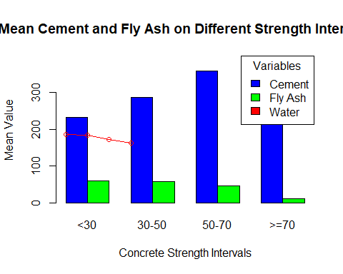
par(mfrow = c(1, 2)) # Set up a 1x2 grid for plots
# Plot 1: Concrete Strength vs. Cement and Fine Aggregate
plot(df_conc$Cement, df_conc$Concrete.strength, xlab = "Cement", ylab = "Concrete Strength",
main = "Concrete Strength vs. Cement & Fine Aggregate", col = "red")
points(df_conc$Fine.Aggregate,col = "red")
# Plot 2: Concrete Strength vs. Cement and Coarse Aggregate
plot(df_conc$Cement, df_conc$Concrete.strength, xlab = "Cement", ylab = "Concrete Strength",
main = "Concrete Strength vs. Cement & Coarse Aggregate", col = "blue")
points(df_conc$Coarse.Aggregate, df_conc$Concrete.strength, col = "blue")
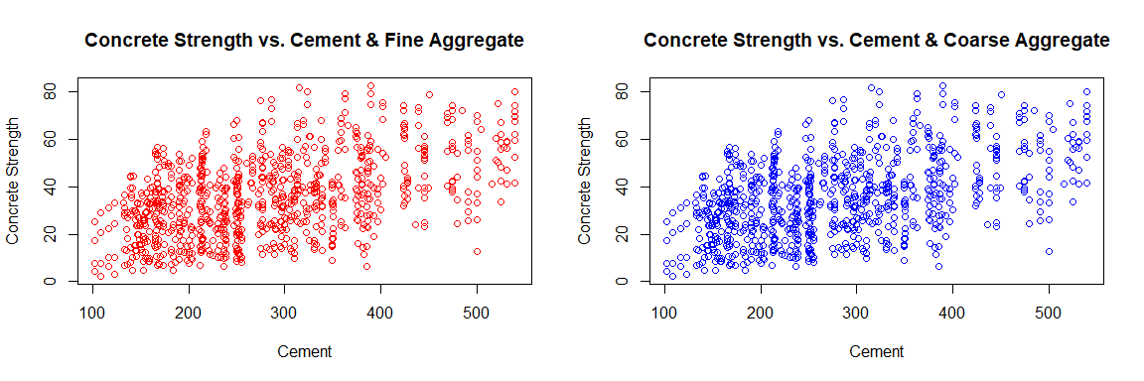
# Define intervals for Concrete Strength
df_conc$Strength_Group <- cut(df_conc$Concrete.strength, breaks = c(0, 30, 50, 70, max(df_conc$Concrete.strength)), labels = c("<30", "30-50", "50-70", ">=70"))
# Calculate mean Cement, Fly Ash, Coarse Aggregate, and Fine Aggregate for each interval of Concrete Strength
aggregate_values <- aggregate(cbind(Cement, Fly.Ash, Coarse.Aggregate, Fine.Aggregate) ~ Strength_Group, data = df_conc, FUN = mean)
# Create a bar plot for Cement, Fly Ash, Coarse Aggregate, and Fine Aggregate on different intervals of Concrete Strength
barplot(t(aggregate_values[, c("Cement", "Fly.Ash", "Coarse.Aggregate", "Fine.Aggregate")]), beside = TRUE,
col = c("darkslategrey", "gray", "#996666", "#666666"),
names.arg = aggregate_values$Strength_Group,
main = "Mean Values on Different Strength Intervals",
xlab = "Concrete Strength Intervals (MPa)", ylab = "Mean Value",
ylim = c(0, 1200)) # Set the y-axis limits to accommodate Coarse Aggregate max value
legend("topright", legend = c("Cement", "Fly Ash", "Coarse Aggregate", "Fine Aggregate"),
fill = c("darkslategrey", "gray", "#996666", "#666666"))
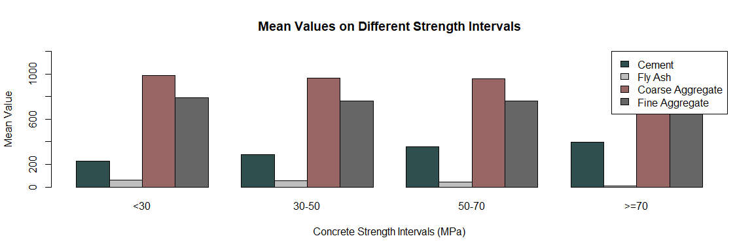
# Define intervals for Concrete Strength
df_conc$Strength_Group <- cut(df_conc$Concrete.strength, breaks = c(0, 30, 50, 70, max(df_conc$Concrete.strength)), labels = c("<30", "30-50", "50-70", ">=70"))
# Calculate mean Cement, Fly Ash, Coarse Aggregate, Fine Aggregate, and Water for each interval of Concrete Strength
aggregate_values <- aggregate(cbind(Cement, Fly.Ash, Coarse.Aggregate, Fine.Aggregate, Water) ~ Strength_Group, data = df_conc, FUN = mean)
# Create a bar plot for Cement, Fly Ash, Coarse Aggregate, Fine Aggregate, and Water on different intervals of Concrete Strength
barplot(t(aggregate_values[, c("Cement", "Fly.Ash", "Coarse.Aggregate", "Fine.Aggregate", "Water")]), beside = TRUE,
col = c("darkslategrey", "gray", "#996666", "#666666", "lightblue"),
names.arg = aggregate_values$Strength_Group,
main = "Mean Values of COmponents on Different Concrete Strength Intervals",
xlab = "Concrete Strength Intervals (MPa)", ylab = "Mean Value",
ylim = c(0, 1200)) # Set the y-axis limits to accommodate Coarse Aggregate max value
legend("topright", legend = c("Cement", "Fly Ash", "Coarse Aggregate", "Fine Aggregate", "Water"),
fill = c("darkslategrey", "gray", "#996666", "#666666", "lightblue"))
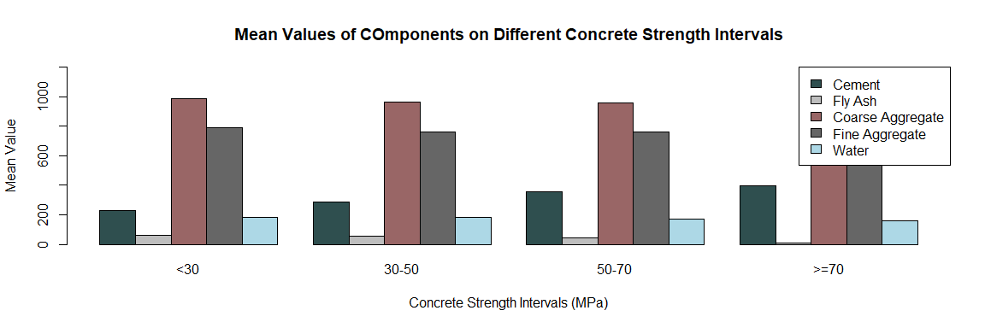
# Define colors based on Superplasticizer values
colors <- ifelse(df_conc$Superplasticizer < 2, "green",
ifelse(df_conc$Superplasticizer >= 2 & df_conc$Superplasticizer < 4, "blue", "darkorange"))
par(mfrow = c(1, 2)) # Set up a 1x2 grid for plots
# Scatter plot of Superplasticizer against Water with colored points based on Superplasticizer range
plot(df_conc$Superplasticizer, df_conc$Water,
xlab = "Superplasticizer (kg in a m^3 mixture)", ylab = "Water (kg in a m^3 mixture)",
main = "Relationship between Superplasticizer and Water",
col = colors)
# Adding a trend line for Water vs. Superplasticizer
abline(lm(df_conc$Water ~ df_conc$Superplasticizer), col = "red")
# Adding a legend
legend("topright", legend = c("< 2", "2 - 4", ">= 4"), col = c("green", "blue", "darkorange"), pch = 2,
title = "Superplasticizer Range")
# Create a second plot to show the effect on response variable (Concrete.strength)
# Scatter plot of Superplasticizer against Concrete.strength with colored points based on Superplasticizer range
plot(df_conc$Superplasticizer, df_conc$Concrete.strength,
xlab = "Superplasticizer (kg in a m^3 mixture)", ylab = "Concrete Strength (MPa)",
main = "Effect of Superplasticizer on Concrete Strength",
col = colors)
# Adding a trend line for Concrete.strength vs. Superplasticizer
abline(lm(df_conc$Concrete.strength ~ df_conc$Superplasticizer), col = "red")
# Adding a legend
legend("topright", legend = c("< 2", "2 - 4", ">= 4"), col = c("green", "blue", "darkorange"), pch = 2,
title = "Superplasticizer Range")
# Adding a legend
legend("topright", legend = c("< 2", "2 - 4", ">= 4"), col = c("green", "blue", "darkorange"), pch = 2,
title = "Superplasticizer Range")
